- GITHUB Repo
https://github.com/queenpink25/CrownSecure-API

API design and implementation
Features
- JWT Authentication - Secure token-based authentication
- User Management - Register, login, update, delete users
- Password Hashing - bcrypt encryption for security
- Auto Documentation - Interactive Swagger UI
- Load Testing - Built-in delay endpoint for performance testing
Tech Stack
- Python 3.10+
- FastAPI
- JWT (python-jose)
- bcrypt
- Uvicorn

- API Documentation
Swagger
- GET User
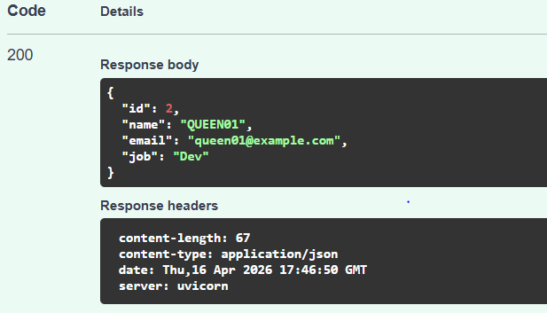

ii) POST User

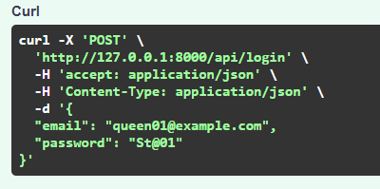

Response
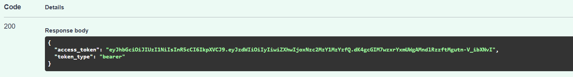

iii)GET API User ID
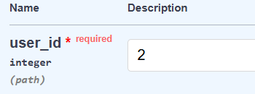

Responses

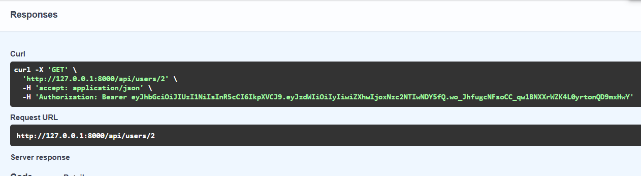

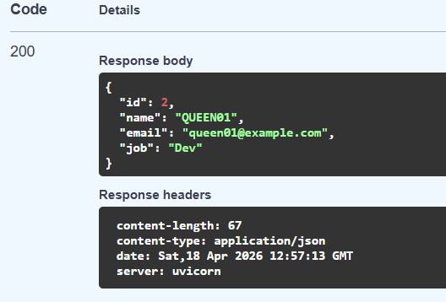

iv) PUT/Update User

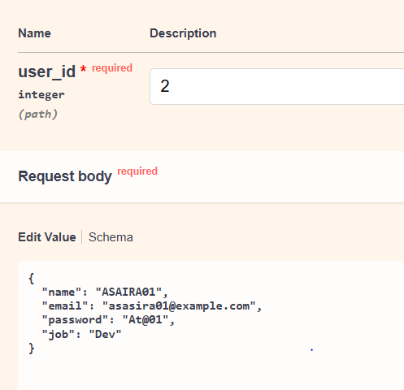

Responses
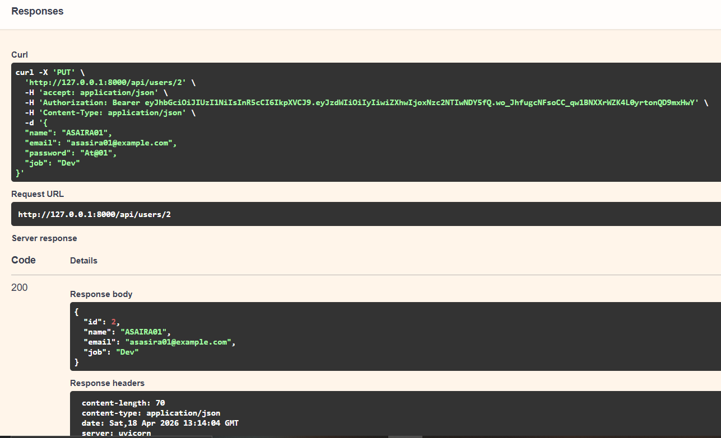

v)DELETE Delete User

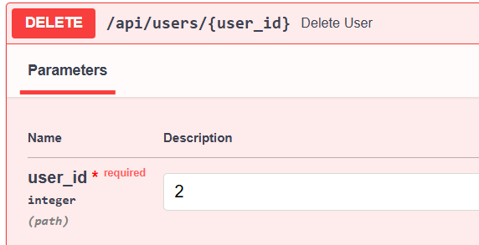

Responses
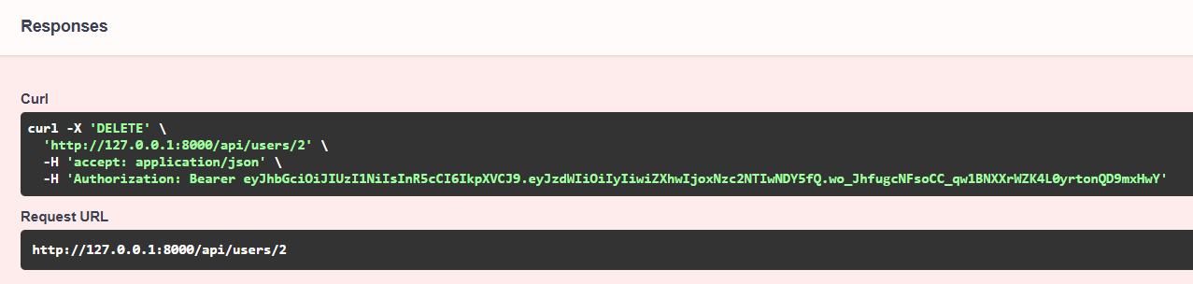

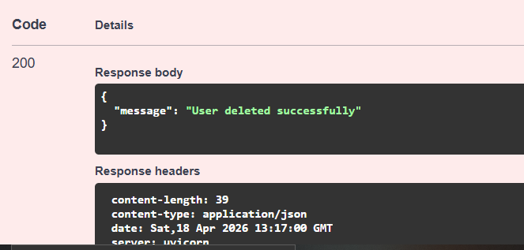

vi)DELAY
Request
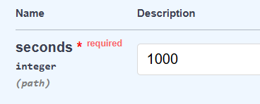

Response
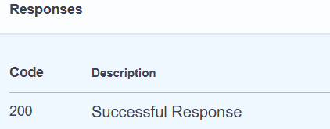

- Test Cases & Execution Results

Test Case | Endpoint | Input | Expected | Result
Valid Token | GET /users/1 | Bearer token | 200 | successful
No Token | GET /users/1 | None | 401 | Successful
Invalid Token | GET /users/1 | wrong token | 401 | Successful
Update User | PUT /users/1 | JSON body | 200 | successful

- Evidence of unit, integration and system testing
Unit Testing

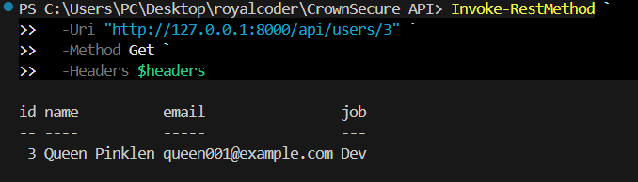
Integration Testing
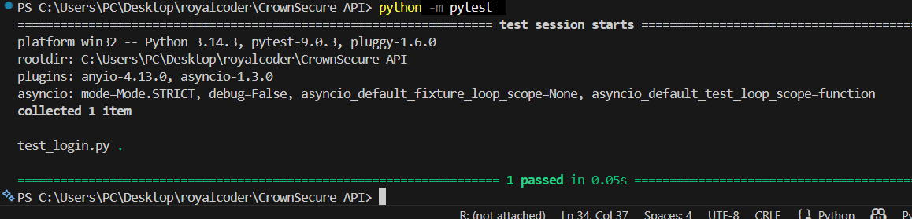
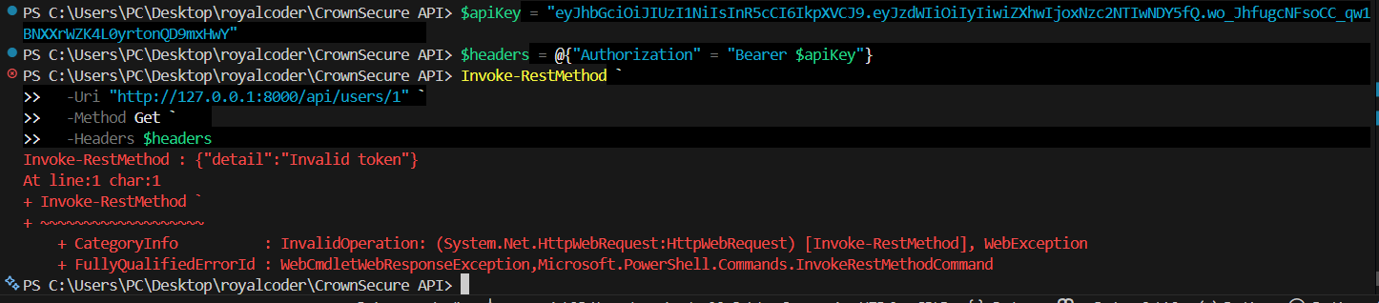
System Testing

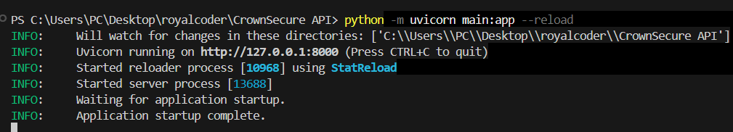

Postman
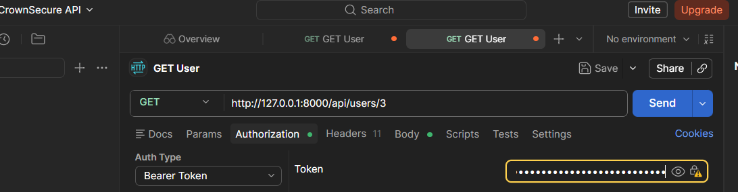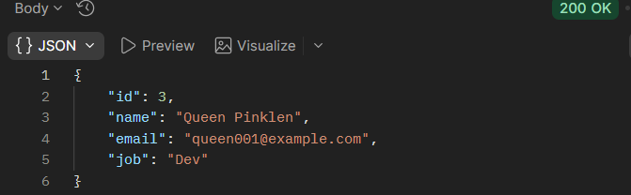

- Automated testing implementation
- CI/CD Pipeline

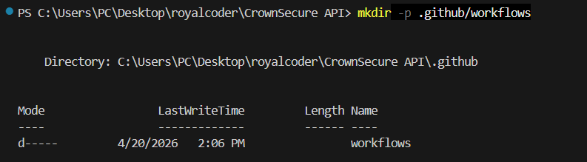
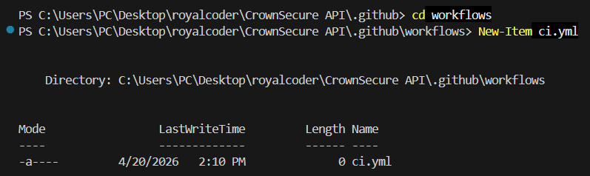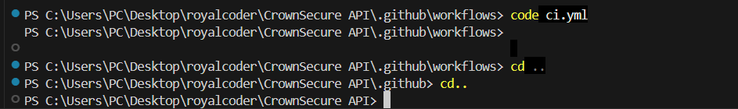
Jwt ci testing
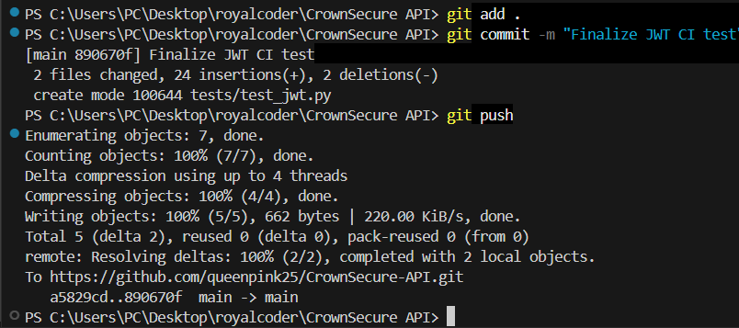

Install dependencies
